**Objectives**

Project Brief

You work for Company ABC, an [asset management company](http://www.wallstreetmojo.com/what-is-asset-management-company-amc/). The CEO of the company wants to understand the global trends in investments so that she can take the investment decisions effectively.

*Business and Data Understanding*

ABC has two minor constraints for investments:

It wants to invest between 5 to 15 million USD per round of investment

It wants to invest only in English-speaking countries because of the ease of communication with the companies it would invest in

For your analysis, consider a country to be English speaking only if English is one of the official languages in that country

You may use this list: Click [here](http://www.emmir.org/fileadmin/user_upload/admission/Countries_where_English_is_an_official_language.pdf) for a list of countries where English is an official language.

These conditions will give you sufficient information for your initial analysis. Before getting to specific questions, let’s understand the problem and the data first.

*1. What is the strategy?*

The Company wants to invest where most other investors are investing. This pattern is often observed among early stage startup investors.

2. **Business objective?**

The business objectives and goals of data analysis are pretty straightforward.

Business objective: The objective is to identify the best sectors, countries, and a suitable investment type for making investments. The overall strategy is to invest where others are investing, implying that the 'best' sectors and countries are the ones 'where most investors are investing'.

Goals of data analysis: Your goals are divided into three sub-goals:

Investment type analysis: Comparing the typical investment amounts in the venture, seed, angel, private equity etc. so that s can choose the type that is best suited for their strategy.

Country analysis: Identifying the countries which have been the most heavily invested in the past. These will be ABC’s favourites as well.

Sector analysis: Understanding the distribution of investments across the eight main sectors. (Note that we are interested in the eight 'main sectors' provided in the mapping file. The two files — companies and file-2 — have numerous sub-sector names; hence, you will need to map each sub-sector to its main sector.)

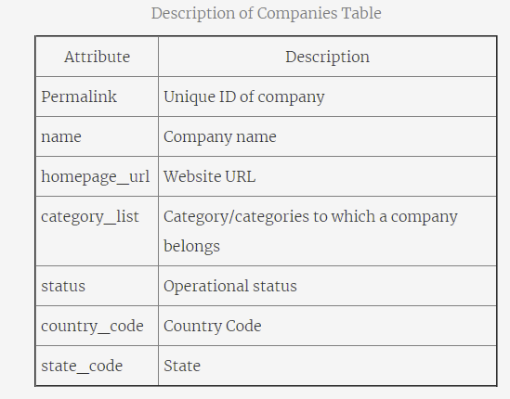

Description of file-2

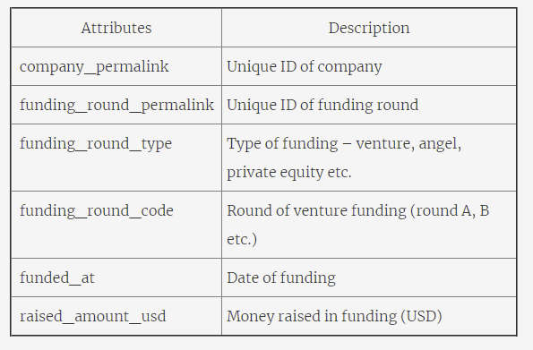

**File-3.csv**: This file maps the numerous **category names**in the companies table (such 3D printing, aerospace, agriculture, etc.) to eight broad **sector names.**The purpose is to simplify the analysis into eight sector buckets, rather than trying to analyse hundreds of them

**Excel File :** Download the Excel spreadsheet and fill in the data acquired from the program